Q. Write a program in python to demonstrate to find missing term.

Aim: To write a program in python to demonstrate to find missing term.

Program:
def solve_five_point(y):
coeffs = [1, -4, 6, -4, 1]
if y.count(None) != 1:
print("Error: Exactly one value must be 'null'.")
return None
missing_index = y.index(None)
total = 0
for i in range(5):
if i != missing_index:
total += coeffs[i] * y[i]
y_missing = -total / coeffs[missing_index]
return missing_index, y_missing
def check_equal_spacing(x):
h = x[1] - x[0]
for i in range(1, len(x) - 1):
if abs((x[i + 1] - x[i]) - h) > 1e-6:
return False
return True
def main():
print("Enter x values (must be equally spaced):")
x = []
for i in range(5):
try:
x_val = float(input(f"x[{i}]: "))
x.append(x_val)
except ValueError:
print("Invalid x value.")
return
if not check_equal_spacing(x):
print("Error: x values are not equally spaced.")
return
print("Enter y values (use 'null' for missing value):")
y = []
for i in range(5):
val = input(f"y[{i}]: ")
if val.lower() == "null":
y.append(None)
else:
try:
y.append(float(val))
except ValueError:
print("Invalid y value.")
return
result = solve_five_point(y)
if result:
idx, missing_y = result
print(f"\nMissing value y[{idx}] = {missing_y:.4f}")
if __name__ == "__main__":
main()

Output:
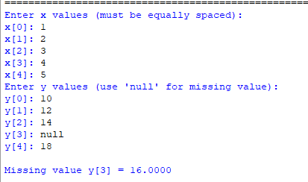

Conclusion: The above program has been executed successfully.

